***Bipolar Junction Transistor (BJT)***

A Bipolar Junction Transistor (BJT) is a three-terminal device which consists of two pn-junctions formed by sandwiching either p-type or n-type semiconductor material between a pair of opposite type semiconductors.

The primary function of BJT is to increase the strength of a weak signal, i.e., it acts as an amplifier. A BJT can also be used as a solid state switch in electronic circuits.

## Types of BJT

There are two types of BJTs −

* NPN Transistor
* PNP Transistor

In this article, we will discuss in detail the working principle of both these types of BJTs.

## NPN Transistor

An npn-transistor is composed of two n-type semiconductor materials which are separated by a thin layer of p-type semiconductor. The two terminals viz. Emitter and Collector are taken out from the two n-type semiconductor and the Base terminal is from the p-type semiconductor.

In BJT symbol, the arrow on the emitter terminal indicates the direction of conventional current in the emitter with forward bias. For npn-transistor, the conventional current flows out of the emitter as indicated by the outing arrow.

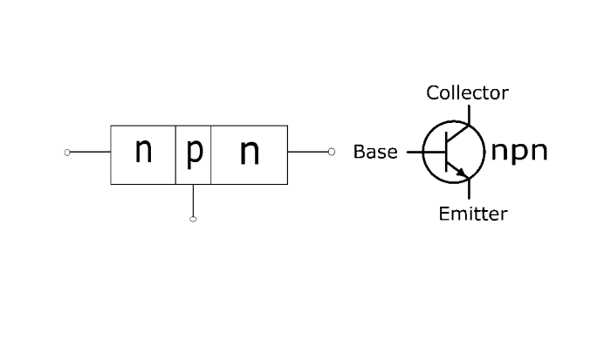

**Important Facts about BJT**

* There are two pn-junctions, hence a transistor may be regarded as a combination of two back-to-back connected diodes.
* The collector region is wider than both emitter and base. The base is much thinner than both emitter and collector. During the transistor operation, a lots of heat is generated at the collector, hence the collector is made larger to dissipate the heat.
* A transistor has three sections of doped semiconductors. The one section is called the Emitter, the other is called the Collector, and the middle section is called the Base and forms two pn-junctions between emitter and collector.
* In general, the emitter-base junction of the BJT is made forward-biased, whereas the collector-base junction is reverse-biased.
* The resistance of forward-biased junction is very small as compared to that of the reverse-biased junction.
* The emitter is heavily doped so that it can supply a greater number of charge carriers (electrons or holes) to the base. The base is lightly doped and very thin, hence it passes most of the charge carriers injected by the emitter to the collector. The doping concentration of the collector region is moderate.

## Working Principle of BJT

The emitter-base junction of BJT is forward-biased, whereas the collector-base junction is reverse biased. The forward bias of the emitter-base junction causes the emitter current to flow and this emitter current entirely flows in the collector circuit. Therefore, the collector current depends upon the emitter current and nearly equal to the emitter current.

### Working of NPN Transistor

With the forward-biased emitter-base junction and reverse-biased collector-base junction, it can be seen that the forward bias causes the flow of electrons from the n-type emitter into the p-type base. This constitutes the emitter current (). As these electrons flow through the p-type base, they tend to combine with the holes.

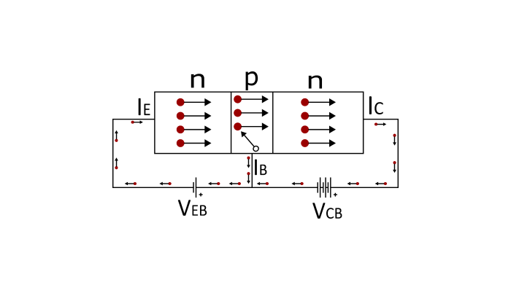

## BJT Biasing

A BJT has two pn-junctions viz. emitter-base junction and collector-base junction. Application of proper DC voltage at the two junctions of the BJT is known as BJT or Transistor Biasing.

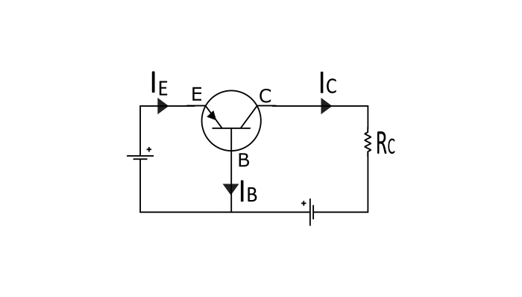

When a transistor used as an amplifier, the emitter-base junction is forward biased and collector-base junction is reverse biased. If the transistor is operated under this bias condition then it is said to be operating in the **active region**.

When both the junctions are forward biased then the transistor is said to be operating in the **saturation region**. The transistor operated in saturation region acts like a closed switch and the collector current becomes maximum.

When both the junctions are reverse biased, the transistor is said to be operating in the **cut off region**. The BJT operated in cut off region acts as an open switch and a very small collector current (in **µA**) flows from emitter to collector. This current is called reverse leakage current and is due to minority charge carriers (electrons in p-region and holes in n-region).

# Transistor Working

## Introduction

The transistor refers to simple components that are mostly used to build different types of electrical devices and different projects. It is an electronic device that is mostly applicable in the electric circuit to amplify the electrical signals as well as allows it as a wide array of electrical devices. The transistor is classified into three different categories like emitter, base, as well as collector. The principal idea that is behind the construction as well as the working principles of the transistor is based on the current flow to the electric circuit.

## What is a transistor?

The characteristics of the transistor are classified into three different categories like input characteristics, output characteristics, and current transfer characteristics. Input characteristics of a transistor describe that value-changing rate in reference to the input voltage when the voltage is constant while output characteristics of a transistor refer to the curve that is obtained by plotting the output current that is against the output voltage when a constant current flowing through the transistor (Huang et al. 2019).

The current transfer characteristics of a transistor refer to an input device that guides to keep the output voltage and input current constant.

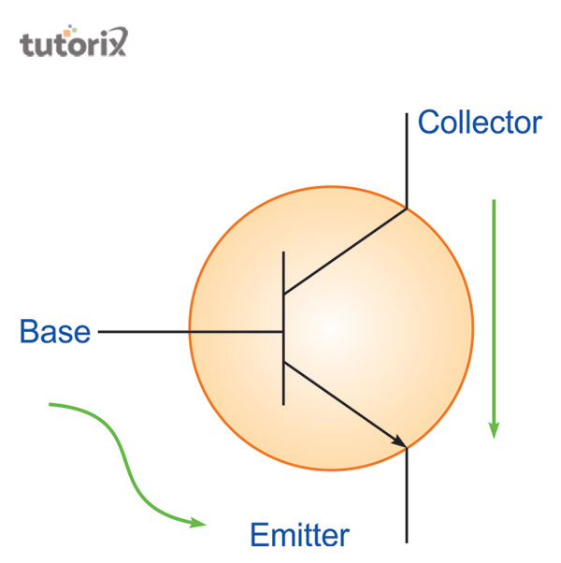

**Figure 1: Construction of a transistor**

## Types of transistor

Several types of transistors are available for use and each type of transistor is used for a specific purpose. The classification of transistors can be categorized into two different types BJT and FET. Bipolar Junction Transistor is commonly known as the BJT and it is just a normal transistor that has two different types of configurations NPN as well as PNP. Field Effect Transistor is commonly known as FET and it is mainly used as a voltage-controlled device. The principal advantage of this type of transistor is that it consists of a high input device . It is measured by the Mega Ohms and it consumed lower power than other types of transistors.

## Working principle of a transistor

The working principle of the transistor proceeds with an anti-parallel diode that forms innovative electronic components that are called components. During the working time, the transistor does not follow the ohms’ law.

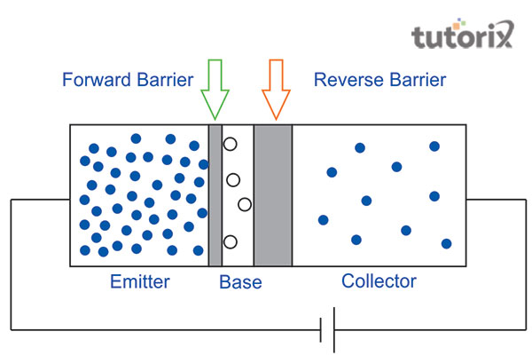

**Figure 2: Working principle of a transistor**

During working three different components of the transistor such as emitter, base as well as collector works s a unit. There are two different types of barriers seen during the working process forward and reverse barriers.

## Application of the transistor

In current times, transistors are used in various aspects. A semiconducting material is used in the formation of a transistor. Both conductive and non-conductive materials are also used.

**Common Emitter Configuration**

In common emitter configuration, base is the input terminal, collector is the output terminal and emitter is the common terminal for both input and output. That means the base terminal and common emitter terminal are known as input terminals whereas collector terminal and common emitter terminal are known as output terminals.

In common emitter configuration, the emitter terminal is grounded so the common emitter configuration is also known as grounded emitter configuration. Sometimes common emitter configuration is also referred to as CE configuration, common emitter amplifier, or CE amplifier. The common emitter (CE) configuration is the most widely used transistor configuration.

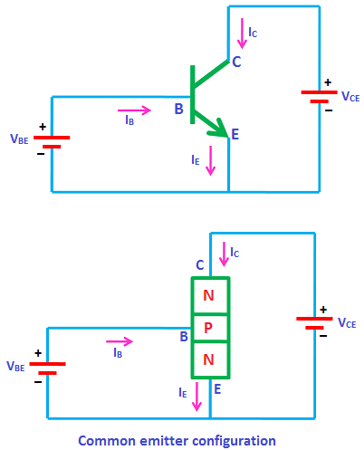

### The common emitter (CE) amplifiers are used when large current gain is needed.

### The input signal is applied between the base and emitter terminals while the output signal is taken between the collector and emitter terminals. Thus, the emitter terminal of a transistor is common for both input and output and hence it is named as common emitter configuration.

### The supply voltage between base and emitter is denoted by VBE while the supply voltage between collector and emitter is denoted by VCE.

### In common emitter (CE) configuration, input current or base current is denoted by IB and output current or collector current is denoted by IC.

### The common emitter amplifier has medium input and output impedance levels. So the current gain and voltage gain of the common emitter amplifier is medium. However, the power gain is high.

### To fully describe the behavior of a transistor with CE configuration, we need two set of characteristics – input characteristics and output characteristics.

**Input characteristics**

The input characteristics describe the relationship between input current or base current (IB) and input voltage or base-emitter voltage (VBE).

First, draw a vertical line and a horizontal line. The vertical line represents y-axis and horizontal line represents x-axis. The input current or base current (IB) is taken along y-axis (vertical line) and the input voltage (VBE) is taken along x-axis (horizontal line).

To determine the input characteristics, the output voltage VCE is kept constant at zero volts and the input voltage VBE is increased from zero volts to different voltage levels. For each voltage level of input voltage (VBE), the corresponding input current (IB) is recorded.

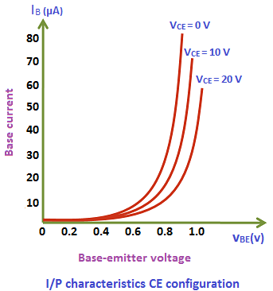

A curve is then drawn between input current IB and input voltage VBE at constant output voltage VCE (0 volts).

Next, the output voltage (VCE) is increased from zero volts to certain voltage level (10 volts) and the output voltage (VCE) is kept constant at 10 volts. While increasing the output voltage (VCE), the input voltage (VBE) is kept constant at zero volts. After we kept the output voltage (VCE) constant at 10 volts, the input voltage VBE is increased from zero volts to different voltage levels. For each voltage level of input voltage (VBE), the corresponding input current (IB) is recorded.

A curve is then drawn between input current IB and input voltage VBE at constant output voltage VCE (10 volts).

This process is repeated for higher fixed values of output voltage (VCE).

When output voltage (VCE) is at zero volts and emitter-base junction is forward biased by input voltage (VBE), the emitter-base junction acts like a normal p-n junction diode. So the input characteristics of the CE configuration is same as the characteristics of a normal pn junction diode.

The cut in voltage of a silicon transistor is 0.7 volts and germanium transistor is 0.3 volts. In our case, it is a silicon transistor. So from the above graph, we can see that after 0.7 volts, a small increase in input voltage (VBE) will rapidly increases the input current (IB).

In common emitter (CE) configuration, the input current (IB) is very small as compared to the input current (IE) in common base (CB) configuration. The input current in CE configuration is measured in microamperes (μA) whereas the input current in CB configuration is measured in milliamperes (mA).

In common emitter (CE) configuration, the input current (IB) is produced in the base region which is lightly doped and has small width. So the base region produces only a small input current (IB). On the other hand, in common base (CB) configuration, the input current (IE) is produced in the emitter region which is heavily doped and has large width. So the emitter region produces a large input current (IE). Therefore, the input current (IB) produced in the common emitter (CE) configuration is small as compared to the common base (CB) configuration.

Due to forward bias, the emitter-base junction acts as a forward biased diode and due to reverse bias, the collector-base junction acts as a reverse biased diode.

Therefore, the width of the depletion region at the emitter-base junction is very small whereas the width of the depletion region at the collector-base junction is very large.

If the output voltage VCE applied to the collector-base junction is further increased, the depletion region width further increases. The base region is lightly doped as compared to the collector region. So the depletion region penetrates more into the base region and less into the collector region. As a result, the width of the base region decreases which in turn reduces the input current (IB) produced in the base region.

From the above characteristics, we can see that for higher fixed values of output voltage VCE, the curve shifts to the right side. This is because for higher fixed values of output voltage, the cut in voltage is increased above 0.7 volts. Therefore, to overcome this cut in voltage, more input voltage VBE is needed than previous case.

**Output characteristics**

The output characteristics describe the relationship between output current (IC) and output voltage (VCE).

First, draw a vertical line and a horizontal line. The vertical line represents y-axis and horizontal line represents x-axis. The output current or collector current (IC) is taken along y-axis (vertical line) and the output voltage (VCE) is taken along x-axis (horizontal line).

To determine the output characteristics, the input current or base current IB is kept constant at 0 μA and the output voltage VCE is increased from zero volts to different voltage levels. For each level of output voltage, the corresponding output current (IC) is recorded.

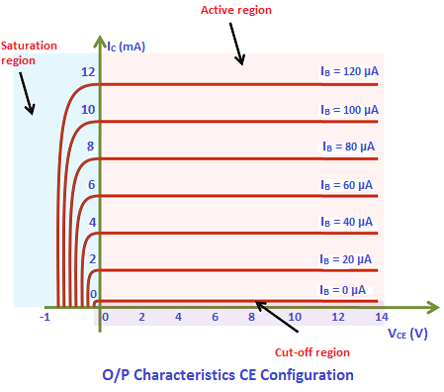

A curve is then drawn between output current IC and output voltage VCE at constant input current IB (0 μA).

When the base current or input current IB = 0 μA, the transistor operates in the cut-off region. In this region, both junctions are reverse biased.

Next, the input current (IB) is increased from 0 μA to 20 μA by adjusting the input voltage (VBE). The input current (IB) is kept constant at 20 μA.

While increasing the input current (IB), the output voltage (VCE) is kept constant at 0 volts.

After we kept the input current (IB) constant at 20 μA, the output voltage (VCE) is increased from zero volts to different voltage levels. For each voltage level of output voltage (VCE), the corresponding output current (IC) is recorded.

A curve is then drawn between output current IC and output voltage VCE at constant input current IB (20 μA). This region is known as the active region of a transistor. In this region, emitter-base junction is forward biased and the collector-base junction is reverse biased.

### This steps are repeated for higher fixed values of input current IB (I.e. 40 μA, 60 μA, 80 μA and so on).

### When output voltage VCE is reduced to a small value (0.2 V), the collector-base junction becomes forward biased. This is because the output voltage VCE has less effect on collector-base junction than input voltage VBE.

### As we know that the emitter-base junction is already forward biased. Therefore, when both the junctions are forward biased, the transistor operates in the saturation region. In this region, a small increase in output voltage VCE will rapidly increases the output current IC.

**Transistor parameters**

**Dynamic input resistance (ri)**

Dynamic input resistance is defined as the ratio of change in input voltage or base voltage (VBE) to the corresponding change in input current or base current (IB), with the output voltage or collector voltage (VCE) kept at constant.

Dynamic input resistance is defined as the ratio of change in input voltage or base voltage (VBE) to the corresponding change in input current or base current (IB), with the output voltage

In CE configuration, the input resistance is very low.

**Dynamic output resistance (ro)**

Dynamic output resistance is defined as the ratio of change in output voltage or collector voltage (VCE) to the corresponding change in output current or collector current (IC), with the input current or base current (IB) kept at constant.

Dynamic output resistance is defined as the ratio of change in output voltage or collector voltage (VCE) to the corresponding change in output current or collector

In CE configuration, the output resistance is high.

**Current gain (α)**

The current gain of a transistor in CE configuration is defined as the ratio of output current or collector current (IC) to the input current or base current (IB).

The current gain of a transistor in CE configuration is defined as the ratio of output current or collector current (IC) to the input current or base current (IB).

The current gain of a transistor in CE configuration is high. Therefore, the transistor in CE configuration is used for amplifying the current.

### Integrated circuits

In an integrated circuit, resistors, diodes, transistors, and capacitors are combined. A chip, made of a silicon wafer is used in combining these. This chip is known as a microchip. In the formation of an integrated circuit, transistors are highly used. An integrated circuit is useful as it consumes very less energy. This is very small as well which is why the size of a circuit is very small and the making cost is low as a result.

### Heat-operated switch

Transistors are used in fire alarms. An important component of a heat-operated switch is a transistor. Based on the surrounding temperature, this resistor responds (Yang et al. 2020). In the case of a high temperature, the resistance of a transistor decrease and the exact opposite is found for a low temperature.

## Conclusion

The circuit of the transistor depends on the three different types of configurations that are the common emitter transistor, common base transistor, as well as common collector transistor. These three circuit configuration of the transistor has their individual characteristics curve. The type of circuit configuration of the transistor is selected based on the requirement of the electric device.